Advancement in Predictive Vehicle Collision Avoidance Technologies & Traffic Simulation

*Submitted in partial fulfillment of the requirements for the degree of*

**Bachelor of Technology**

**in**

**Electronics and Communication with Specialization in Biomedical Engineering**

*By*

**Tushar Pati Tripathi (21BML0105) Rohan Joshi (21BML0131) Aiyushi Srivastava (21BML0155)**

Under the guidance of

**Dr. Ravi Kumar C.V.**



*November, 2024*

# DECLARATION

I hereby declare that the thesis entitled “**Advancement in Predictive Vehicle Collision Avoidance Technologies & Traffic Simulation**" submitted by me, for the completion of the course “BECE497J – Project 1" to the school of electronics engineering, vellore institute of technology, vellore is bonafide work carried out by me under the supervision of **Dr. Ravi Kumar C.V**.

##### I further declare that the work reported in this thesis has not been submitted previously to this institute or anywhere.

Place : Vellore Date :14/11/24

**Signature of the Candidate**

# CERTIFICATE

This is to certify that the thesis entitled “**Advancement in Predictive Vehicle Collision Avoidance Technologies & Traffic Simulation**” submitted by **Tushar Pati Tripathi(21BML0105), Rohan Joshi(21BML0131) and Aiyushi Srivastava(21BML0155), SENSE, VIT,** for the completion of the course “BECE497J – Project 1”, is a bonafide work carried out by him / her under my supervision during the period, 20. 07. 2024 to 14.11.2024, as per the VIT code of academic and research ethics.

##### I further declare that the work reported in this thesis has not been submitted previously to this institute or anywhere.

Place : Vellore

Date : 14/11/24 **Signature of Guide**

**Internal Examiner**

# ACKNOWLEDGEMENTS

We are grateful for the life, good health and protection the Almighty God granted me during the course of this final year project. We are also very grateful for our family and dear friends for the unwavering support and encouragement especially during these unpredictable times.

We would like to thank Dr. Ravi Kumar C.V. in a special way for the immense support, encouragement and the commitment of his time and knowledge to ensure that we achieved the set objectives for this project.I am deeply grateful to my guide, who have shared their knowledge and guided me with patience and wisdom. Your dedication and encouragement have inspired me and played a huge part in my growth and achievements. May the Almighty God richly bless you.

#### Student Name

Aiyushi Srivastava(21BML0155) Rohan Joshi(21BML0131)

Tushar Pati Tripathi(21BML0105)

#### Executive Summary

Predictive vehicle collision avoidance and traffic simulation technologies enhance road safety, reduce congestion, optimize the flow of traffic and revolutionize transportation while assuming different trends heralding spectacular changes in transportation. The systems work with sensors, artificial intelligence, and data analytics to monitor real-time traffic patterns and make proactive traffic management decisions to avert accidents.

Currently, all that data from sensors onboard, V2X, and GPS is integrated with AI and machine learning-based support for hazard detection and prediction. Some of the major innovations include sensor fusion to better detect hazards, AI-based predictive models to predict collisions in advance, advanced AEB to prevent collisions through ultimate emergency braking, and V2V/V2I communications, developing awareness of situations and hazard detection.

Strategically, these improvements protect road users through safety enhancement, decreased traffic congestion, support the development of autonomous vehicles, and also guide future infrastructure policies. However, promising predictive collision and simulation technologies are expected to be significantly diminished in traffic fatalities, to be more efficient, and less painful in a journey toward autonomous driving, requiring continued R&D, collaboration, and regulation.

### CONTENTS

|  |  |
| --- | --- |
| **CONTENTS** | **Page No.** |
| **Declaration** | **i** |
| **Certificate** | **ii** |
| **Acknowledgement** | **iii** |
| **Executive Summary** | **iv** |
| **Table of Contents** | **v** |
| **1 . INTRODUCTION** | **8** |
| 1.1 Literature Review | **9** |
| 1.2 Research Gap | **9** |
| 1.3 Problem Statement | **10** |
| **2 . PROJECT OBJECTIVE** | **11-15** |
| **3. PROPOSED WORK (as applicable) .** | **16-23** |
| 3.1 Design Approach / System model / Algorithm . | **17-23** |
| **4 . SIMULATIONS** | **24-28** |

|  |  |
| --- | --- |
| **5. RESULT ANALYSIS** | **29-31** |
| **6 .CONCLUSION AND FUTURE WORK** | **31** |
| 6.1 Summary | **32** |
| 6.2 Limitations and constraints | **32** |
| 6.3 Improvement/ Future work | **33** |
| 6.4 Challenges | **33** |
| **7 . SOCIAL AND ENVIRONMENTAL IMPACT** | **34** |
| **8. WORK PLAN** | **35** |
| 8.1 Timeline | **35** |
| 8.2 Individual contribution | **36** |
| **9. COST ANALYSIS** | **36** |
| **10. PROJECT OUTCOME** | **37** |
| **11.REFERENCES** | **38** |

1. **INTRODUCTION**

#### Abstract

Millions of people around the world are being killed by accidents at a shocking rate. Safety applications can play a key role in minimizing the frequency of road accidents. It is asserted that an accident can be prevented if a warning is provided to a driver just one second before it occurs. Hence, Intelligent transportation systems (ITSs) play a crucial role in and avoid such accidents. The main aim of this system is to control traffic. For this, VANETs are used (Vehicular ad hoc network). It is a type of IVC or inter vehicle communication. There are many applications of VANETs going with IVC. Some examples are: Improve the traffic safety, reduce accidents, Locate vehicles, Up-to-date traffic information.

#### Background

Global facts 1.35 million people die every year as a result of road traffic crashes. The 2030 Agenda for Sustainable Development has set an ambitious target of halving the global number of deaths and injuries from road traffic crashes by 2020. Road traffic crashes cost most countries 3% of their gross domestic product. More than half of all road traffic deaths fall among vulnerable road users: pedestrians, cyclists, and motorcyclists. 93% of the world's fatalities on the roads occur in low- and middle-income countries, although these countries hold approximately 60% of the world's vehicles .

Road traffic injuries form one of the major reasons for death and life-long disability globally. The World Health Organization reports that some 1.24 million people die annually

On the world's roads, 2050 million suffer non-fatal injuries. Globally, road traffic injuries are accounted as the number one cause of death of young people aged 15-29 years and are ranked at the top three causes of deaths of people aged 15-44 years. In Africa, the number of road traffic injuries and deaths have been rising over the past three decades. The WHO African Region had the highest number of deaths from road traffic injury rates in the world, at 26.6 per 100,000 population according to the 2015 Global status report on road safety.

In Uganda, the accident-severity index is 24 people killed per 100 road crashes. Average a loss of 10 people in Uganda per day from road traffic crashes, the highest in East Africa. The overall annual cost is estimated to be approximately UGX 4.4 trillion ($ 1.2 billion), 5% of Uganda's gross domestic product (GDP) . Road infrastructure in Uganda is generally not safe. Most of the roads are single carriageway and do not have a median, with many of them having steep shoulders and few overtaking possibilities, contributing to many head-on collisions. This high number of fatalities from road crashes can be attributed to factors such as reckless driving, over speeding, drunk-driving or alcoholism, inadequate road traffic signs, incompetent drivers or riders, among other factors.

A number of measures have been put forward in attempts to curb the high number of deaths from road accidents. Some of these include:

Launched traffic operations such as Fika Salama. Fika Salama was an operation that was launched by Uganda police in partnership with Uganda National Roads Authority and Ministry of Works and Transport and several health facilities. This was after increased road accidents that kept on occurring on Kampala-Masaka road. It was aimed at sensitizing people on how to use roads safely after harrowing road accidents that had been happening for the last six months.

Licensing and inspection of driving schools. To ensure that the driving schools and instructors are teaching individuals to drive with the correct techniques as well as doing so within the recommended standards under the government.

This system project recorded the road crashes or accidents digitally under the digital road crash data system. This was done so as to collect data regarding the accidents taking place on Ugandan roads and to apply such data and come up with sustainable solutions to the problem of road safety .

ITS are important systems that assist to avoid the happening of road accidents. Management of traffic efficiently is the main goal of ITS because it will enable us to make roads smart and safe. Vehicular ad hoc networks (VANETs) are utilized as backbone networks of the ITS structure in order to achieve this goal. Vehicles should act as mobile nodes in a special mobile ad hoc network or so-called vehicular ad hoc network (VANET). There are two major types of entities in it, like vehicles and access points. The access points can be employed as an access point for vehicles due to its reliability, online most of the time, and connectivity with the internet. VANET provides V2V and V2I transmission wireless transmissions. VANET also has some distinguishing features that define it from other mobile ad hoc networks. By communicating with one another, the vehicles provide an enormous scope for the development of new driver support systems. These kinds of technologies will be able to distribute and collect information about other vehicles, as well as on traffic flow and the environment, in real life time. These data will be processed and analyzed in order to provide the user with useful information and make driving easier.

#### Problem Statement

Despite all of the above-mentioned preventive measures that have been mentioned in an attempt to combat the problem of road safety, the cases of road accidents are still aggressively high.

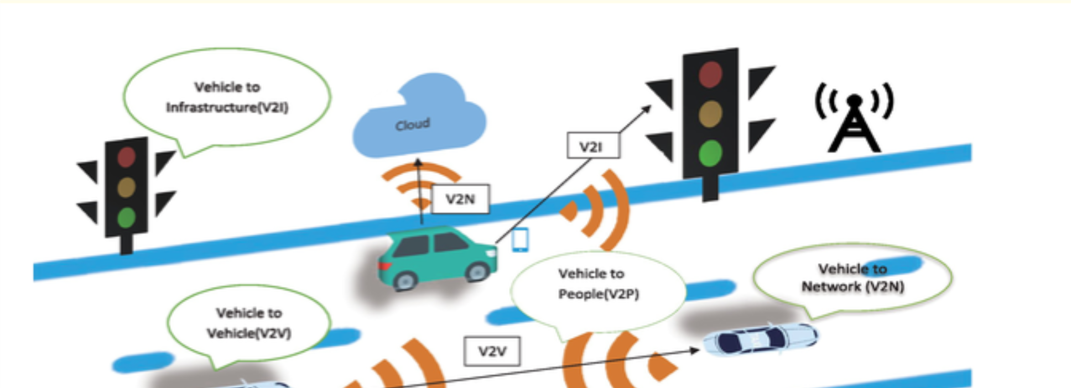This is why there is a necessity of allowing reliable communication for vehicles to communicate with each other and to distribute some of the decision-making

activities to a smarter, intelligent system that can use information obtained from the exchange of messages for detecting possible collisions and then to take automatic actions to avoid them. V2V communication enables vehicles to exchange messages among themselves with the aim of warning drivers of impending accidents and preventing crashes. The NHTSA believes that V2V technology may save 82 percent of multi-vehicle crashes.

### LITERATURE REVIEW :

|  |  |  |  |  |  |  |  |  |
| --- | --- | --- | --- | --- | --- | --- | --- | --- |
| **Re** | **Publisher** | **Date** | **Focus/Scope** | **Methodolo** | **Test Data** | **Results** | **Merits & Demerits** | **Future Scope** |
| **f** |  | **of** | **of Paper** | **gy** |  |  |  |  |
| **No** |  | **Journ** |  |  |  |  |  |  |
| **.** |  | **al** |  |  |  |  |  |  |
| 1 | IEEE | 2022 | Machine | Deep | Real-time | 95% accuracy | High accuracy, but | Focus on |
|  | Transactions |  | learning for | Learning | vehicle | in collision | computationally | real-time |
|  | on ITS |  | predictive | Neural | sensor | prediction | intensive. | deployment for |
|  |  |  | vehicle | Networks | data |  |  | autonomous |
|  |  |  | collision |  |  |  |  | vehicles |
| 2 | Springer: | 2021 | Traffic | Multi-Agent | Traffic flow | Improved traffic | Simulated data limits | Integration with |
|  | Advances in |  | simulation | Simulation | data, | flow with 30% | generalization; high | real-world traffic |
|  | Simulation |  | models for |  | synthetic | fewer collisions | simulation cost. | management |
|  |  |  | vehicle |  | dataset |  |  | systems |
|  |  |  | avoidance |  |  |  |  |  |
| 3 | Elsevier: | 2020 | Comparative | SVM, | Crash | SVM | Good performance in | Incorporating |
|  | Transportatio |  | analysis of ML | Decision | incident | outperformed | sparse data; | more data and |
|  | n Research |  | algorithms for | Trees | data | decision trees | overfitting in decision | hybrid models |
|  | Part C |  | collision |  |  | in predictive | trees. |  |
|  |  |  | avoidance |  |  | accuracy |  |  |
| 4 | ACM Digital | 2023 | Predictive | Reinforcem | Live traffic | 20% | Real-time | Training on |
|  | Library |  | analytics for | ent | data | improvement in | adaptability, but | diverse traffic |
|  |  |  | real-time | Learning |  | real-time | requires extensive | conditions |
|  |  |  | collision |  |  | response rate | training data. |  |
|  |  |  | avoidance |  |  | over traditional |  |  |
|  |  |  |  |  |  | systems |  |  |
| 5 | MDPI | 2022 | IoT sensors for | IoT-based | Sensor-ge | Accurate | High sensor | Development of |
|  | Sensors |  | enhancing | ML | nerated | detection of | accuracy, but | low-cost |
|  |  |  | vehicle | algorithms | vehicle | potential | potential hardware | IoT-based |
|  |  |  | collision |  | data | collisions with | limitations in older | solutions |
|  |  |  | prevention |  |  | 85% reliability | cars. |  |

#### VANET Architecture:

The communication between vehicles or between a vehicle and an RSU is done through a wireless medium called WAVE. The main components of the system are the application unit (AU), OBU and RSU. Normally the RSU hosts an application that provides services and the OBU is a peer device that uses the services provided. The application may reside in the RSU or in the OBU; the device hosting the application is known as the provider and the device utilizing the application is termed as the user. There will be a set of sensors on every vehicle to gather and process the information then send it.

As a message to other vehicles or RSUs over the wireless medium; it also carries single or multiple AU that make use of the applications offered by the provider making use of OBU connection capabilities. The RSU can also connect to the Internet or to another server which allows AU's from multiple vehicles to connect to the Internet.

#### On Board Unit (OBU):

An OBU is a wave device normally mounted on-board a vehicle used for exchanging information with RSUs or with other OBUs. It consists of a resource command processor (RCP), and resources include a read/write memory used to store and retrieve information, a user interface, a specialized interface to connect to other OBUs and a network device for short range.

The OBU is connected to the RSU or other OBUs over a wireless link based on the IEEE 802.11p radio frequency channel and is responsible for communications with other OBUs or RSUs; it also offers communication services to the AU and forwards data on behalf of other OBUs on the network. Main functions of the OBU are wireless radio access, ad hoc and geographical routing, network congestion control, reliable message transfer, data security and IP mobility .

#### Application Unit (AU):

The AU is the device equipped within the vehicle that uses the applications provided by the provider using the communication capabilities of the OBU. The AU can be a dedicated device for safety applications or a normal device such as a personal digital assistant (PDA) to run the Internet, the AU can be connected to the OBU through a wired or wireless connection and may reside with the OBU in a single physical unit; the difference between the AU and the OBU is notional. The AU communicates with the network only through the OBU that assumes all mobility and networking tasks.

#### Roadside Unit (RSU):

The RSU is a wave device normally fixed along the road side or in dedicated locations such as junctions or near parking spaces. Equipped with one network device for a dedicated short range communication based on IEEE 802.11p radio technology, the RSU can further be equipped with other network devices so as to be used for the purpose of communication. Within the infrastructural network. According to C.C. Communication Consortium, the main functions and procedures associated with the RSU are extending the communication range of the ad hoc network by re-distributing the information to other OBUs and by sending the information to other RSUs in order to forward it to other OBUs.

### INTELLIGENT TRANSPORTATION SYSTEM:

Vehicular ad-hoc network or VANET is also known as intelligent transportation system (ITS). The Intelligent transportation system (ITS) has two types. In the first one the V2V or inter vehicular communication: In this, vehicles talk to each other. Vehicle to road communication (V2R) describes the case in which vehicles talk to roadside equipment. Here, each vehicle, which lies within the active network, acts as a sender, receiver, and router to forward information to the vehicular network or transportation agency play a crucial role in network session to be secured, safe the data which travels from one node to another node and free flow of traffic.

#### Vehicular Ad Hoc Networks (VANETs):

Vehicular Ad-Hoc Networks allow Dedicated Short-Range Communications of vehicles in the

5.9 GHz band, based on the IEEE 802.11p standard. They support Intelligent Transport Systems with both, V2V) and (V2I) communications for applications in the both the near and far environment Vehicular Ad hoc Networks are formed applying the principles of mobile ad hoc networks and constitute a subcase of Mobile Ad hoc Networks. However, they differ from MANETs since their end-to-end connectivity is not guaranteed and the vehicles (i.e. the nodes of the network) are highly mobile. Moreover, they can scale up to very large networks, but the probability that they split into parts is high . VANETs use any wireless communication technology to generate the networks enhancing Vehicle-to-Vehicle communication, as well as vehicle-to-infrastructure communication. VANETs are prone to partitioning, as their topology is highly dynamic. This fact implies that there will most probably be many disconnections during those changes in structure in their network. This characteristic makes the designing of an efficient solution to disseminate data in a particular way between vehicles a very difficult challenge in the area of V2V communications.

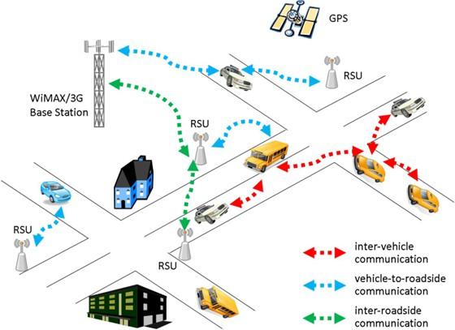

Figure : Illustration of a Vehicular Ad Hoc Network

#### Vehicle to vehicle communication (V2V):

Vehicle to vehicle (V2V) communication performs the operation (sender, receiver and broadcasting) between vehicles. In vehicle to vehicle or inter vehicular communication has two types of message forwarding. First one is Naïve broadcasting and another one is intelligent broadcasting. In naïve broadcasting, vehicles send broadcast messages periodically and at regular intervals. In this method, a broadcast message is generated by the in-front vehicle and the receiving vehicle sends its own broadcast message to other vehicles behind it. The prime disadvantage of this method is that the large number of collisions occurs due to the broadcasting of the whole process and the delivery of messages becomes slow. In intelligent broadcasting, if the vehicle detects that they receive the same message from behind, it assumes that at least one vehicle in the back has received it and stops broadcasting. The assumption is that the vehicle in the back will be responsible for moving the message along to the rest of the vehicles.

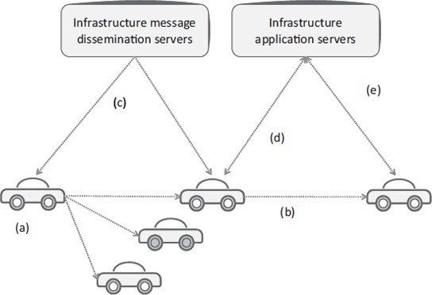

(a) V2V local broadcast; (b) V2V multi-hop forwarding; (c) I2V local broadcast; (d) V2I bidirectional communications; (e) indirect V2V

#### Vehicle-to-Roadside Communication:

The vehicle-to-roadside communication configuration is responsible for single hop broadcast where all vehicle equipment receive the broadcast message from the roadside equipment in that neighborhood. Vehicle to Roadside communication configuration offers a high-bandwidth link between a vehicle and roadside equipment for the assured traffic flow. The distance between two roadside units may be up to one kilometer or less, In heavy traffic the road side unit provides the high data rates to be maintained. For example when broadcasting dynamic speed limits, according to its internal timetable and traffic rules the roadside equipment will determine the appropriate speed limits. The roadside unit sends the broadcast message periodically when it detects the speed limit and will compare any geographic location or directional limits with vehicle data to check whether the speed limit warning is applicable to any of the vehicles in the encircled area. In case a vehicle does violate the speed limit given by the timeline database then the road side unit sends a message in either an auditory or visual warning to ask the driver, he should slow his speed.

#### Safety Applications Addressed by V2V:

The possible applications of V2V safety include driver safety warnings such as: Emergency electronic brake lights warning, forward collision warning, intersection movement assist

warning, blind spot warning, lane change warning, do not pass warning, Control Loss Warning, Bus Driver Warning vehicle making a right turn in front of a bus and so on.

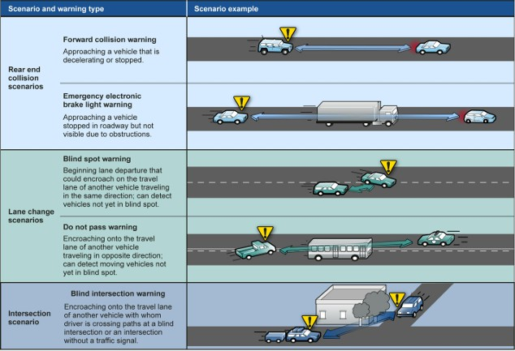

Figure : Examples of safety warnings addressed by V2V and their descriptions

### OBJECTIVE

The main aim of the research project was to design a communication-based collision avoidance model for autonomous cars. This research project propounded to design a communication-based collision avoidance model for autonomous automobiles. The aim was to enhance safety and reduce the risk of accidents by allowing autonomous vehicles to communicate and coordinate their actions in an attempt to avoid collisions more effectively.

The position, speed, and intended maneuvers of each car would be exchanged between the vehicles themselves and with infrastructure through V2V and V2I communications technologies. The information would then be processed within the control system of the autonomous vehicle looking forward in the timeline so that the evasion maneuvers like braking or acceleration or lane change can be executed before collision is imminent.

The model would also consider the traffic density, road conditions, and weather conditions in its decision-making process. Exploiting communication and coordination, the model would enable

the autonomous vehicle to respond sooner and more effectively to changes in the traffic environment, thereby creating a safer and more efficient transportation system.

The specific objectives of the research were:

1. In the proposed communication system, the accident avoidance technique is deployed where the accidents like scenarios are detected before collision and emergency messages are communicated to concerned entities instantly.
2. The vehicles are deployed with drivers facing unusual health issues, for instance, dizziness and fatigue. They communicate the warning messages with nearby base units or RSUs that further forward them to nearby ambulance services and hospitals.
3. Know some of the prominent traffic conditions in which most road accidents are accounted for- intersections, curves, lane change etc
4. To simulate an algorithm that will use the data (real time) given to issue the right collision avoidance warning to the car.
5. Design scenarios where the driver of the car is warned of potential collision, and how the autonomous vehicle would respond to prevent collision.

#### Working of the algorithm

This algorithm for forward collision avoidance calculates the safe braking distance dS as a function of speed and the GPS coordinates of the cars.

From Newton's laws of motion:

s =ut+ 1/2at2 (3.1)

whereby s is the distance covered by the leading vehicle, u is its initial speed, t is the time taken to cover the distance s, and a is the acceleration of the leading vehicle. Assumption is that the leading vehicle is moving at a constant speed, hence acceleration a = 0. time = distance speed hence: Distance to Collision

DTC =UA* -dR/Ur (3.2)

where dR is the range between the vehicles based on the Haversine formula and Ur is the relative velocity between the two cars

Ur = Ub-Ua (3.3)

where: Ub is the speed of the leading vehicle and Ua is the speed of the following vehicle But

this would not be practical since the cars will keep on accelerating as they move. Hence: From

v2 = u2 +2as (3.4)

and

v =u+at (3.5)

t = ((Ur + Ur^2+2as^2)*Ua) / alv (3.6)

where alv is the acceleration of the leading vehicle The equation for t above the time to collision. Hence the distance to collision DTC can be calculated from;

DTC = Ur+ U2 r+2as2 alv Ua (3.7)

There are three levels of thresholds de ned for the warning distances and they take into account the parameters:

* Speed
* Acceleration
* Distance between the vehicles, DTC

For whichever speeds or distances at any point in time, warnings will be triggered when the DTC is less than the three thresholds.

Threshold 1

(3.8)

From equation 3.4 But Distance = Speed time, hence

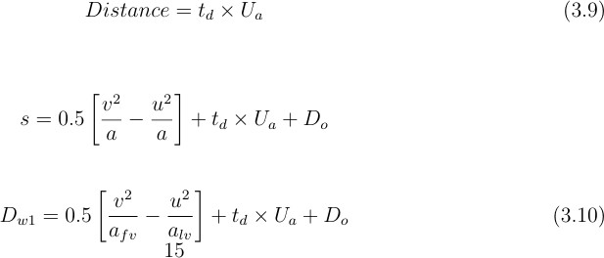

Where: v is the nal speed of the following vehicle and u is the initial speed of the following vehicle. afv is the acceleration of the leading vehicle, alv is the acceleration of the following vehicle, td is the delay time or brake time, Ua is the speed of car A and Do is the distance between the following vehicle when/ if they stop.

Threshold 2

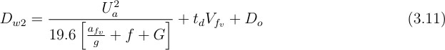

Where: g is the acceleration due to gravity, G is universal gravitational constant, Do is the distance between the following vehicles when/ if they stop. f is the frictional coefficient based on the speed and it is provided by the range of values.

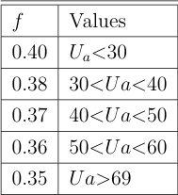

Table : Range of values for the frictional coefficient f based on the speed

##### Explanation:

* The algorithm starts.
* The three distance warnings to be calculated are going to make use of the various input values obtained through the messages exchanged over the network. Based on the values that it has been provided with, it will send one of the three appropriate alarm signals: Dw1,Dw2, and Dw3.
* If the time to warning (tw1) is less than the GPS update period tgps, the first warning Slow down vehicle on the same lane is issued to the appropriate vehicle. Otherwise, the algorithm steps on.
* If the time to warning (tw2) is less than tgps, the second warning Brake or change lanes if there is no incoming car! is issued to the appropriate vehicle.
* If the time to warning (tw3) is less than the GPS update period, an emergency braking warning is sent to the vehicle recommending a brake-and-steer maneuver
* 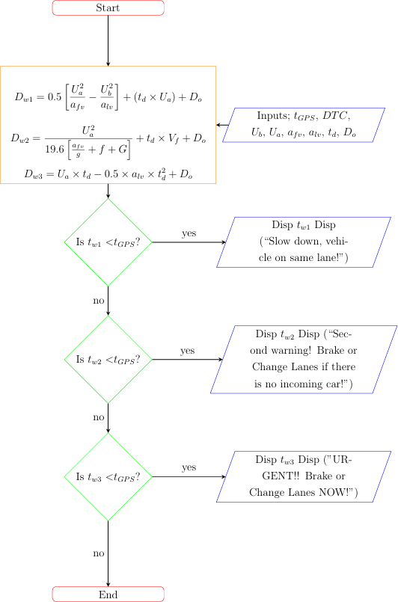The algorithm completes

+

#### Intersection Movement Assist (IMA):

IMA warns the driver of a vehicle when it is unsafe to enter an intersection because the probability of a collision with one or more vehicles at intersections is high, both when a signal is present (a controlled intersection) and when only a stop or yield-sign is present (an uncontrolled intersection). The figure below represents one possible IMA scenario.

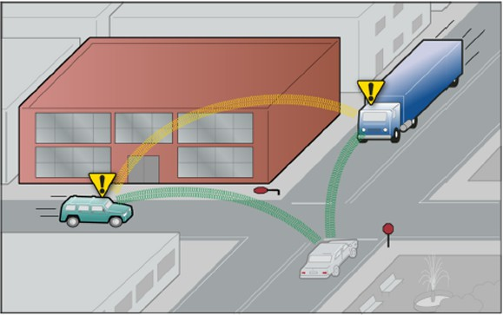

Figure : Two vehicles at potential risk of collision at intersection

Here, the chance of collision of car and truck is because those approaching drivers can't see each other or the stop sign for sure. It will probably be disabled both for those approaching drivers who are going to get a warning of an upcoming collision so they will have enough time to take actions to prevent it.

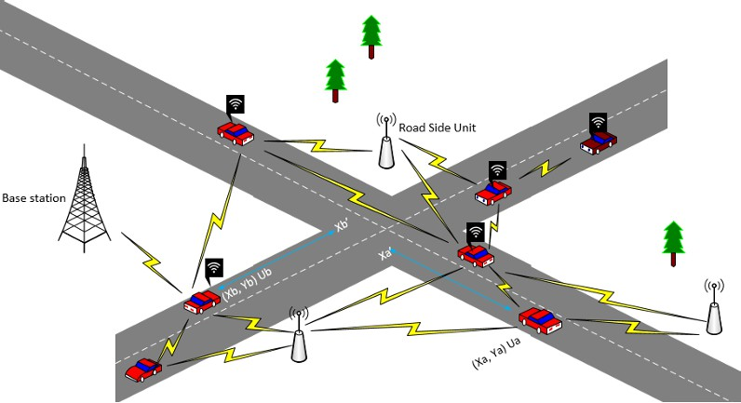

In the communication illustration of Figure, cars A and B (marked with coordinates) are approaching the junction through which all the cars communicate with each other. Without V2V,

the two cars, if over speeding, are bound to collide at the intersection. But with V2V, another car would notify to reduce speed and allow it to pass the intersection first before a collision can occur.

In Figure 3.4, the GPS coordinates for car B, moving at Ub, are (Xb, Yb) and the GPS coordinates for car A, moving at speed Ua are: (Xa, Ya). After time t, car B will have moved to the intersection at coordinates (Xb, Yb ) and car will have reached at the coordinates (Xa ,Yb ).

The Algorithm how it works

* The algorithm takes as inputs the messages exchanged among the vehicles in vehicular ad hoc network.
* It will then compute the amount of time each of the vehicles will take to reach the intersection. Time is measured in distance/speed

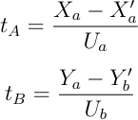

where tA = time at which the car A reaches the intersection, tB = time at which the car B reaches the intersection to reach the intersection B.

* The algorithm then checks whether the vehicles will arrive almost simultaneously within a maximum allowable threshold value at the intersection point. If the vehicles will successfully cross the intersection with an admissible time difference, then no warning signals are issued.
* But if the algorithm determines that the time is below the threshold, then it will calculate the final velocities Va and Vb for both of the cars A and B to which they must be reduced before reaching the crossroads. They are determined from:

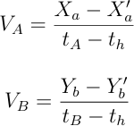

Where th is the threshold time below which it is not safe to continue traveling at the same speed towards the intersection.

* The algorithm issues the warnings with the recommended speed values to either or both of the cars to move slower. The automobile responds to the attempted collision and slows down to avoid the collision.
* The algorithm terminates.

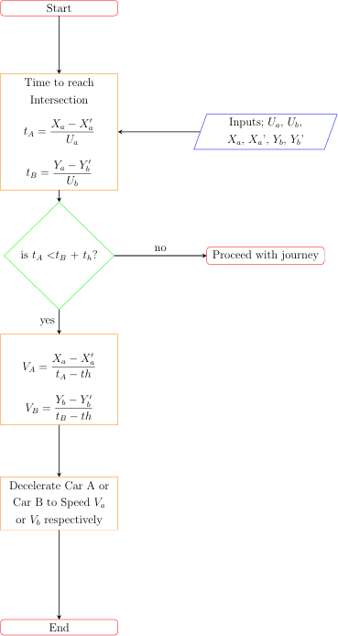

#### The Communication Model:

Due to its high speed and very low latency, the VANET is deployed over a 5G Cellular Network.The cars will speak to each other through a wireless link that is either in the routers/On Board units mounted on each vehicle/vehicular node. Each node in the Vehicular Ad hoc Network acts both as the participant and the router of the network, since nodes communicate with each other through their intermediate nodes that lie within their transmission range. The

VANET will have a range beyond which the vehicles will not be able to communicate. The On-Board Units,or OBUs that connect the vehicles to the 5G network will determine their

positions and dynamic parameters with the help of a GNSS (Global Navigation Satellite system) module. Graphical interface in-vehicle tablets can also be mounted inside the cars for information from the mobile router to be viewed.

#### Role of Base Stations

All the information transmitted to every vehicle is through the basic stations BSs that deploy along the road side. Two vehicles can communicate with each other directly if Euclidean distance between two vehicles is less than a threshold value. This makes the VANET topology dynamic by splitting and merging over time due to the movement of vehicles. Then by vehicle to vehicle communication, all the vehicles in a cluster could receive or transmit messages. The Base Station here will act as a controller that holds Forming decisions for the automobiles based on presented scenarios. One of them is that if the collision avoidance decision taken by a car in VANET is probably not the best, it will decide on a better option for the automobile to make.

#### The Road Side Units roles

The units placed beside the road help improve the mesh network by receiving the signals that are broadcast from the cars and then rebroadcasting them. This goes a long way in helping when the cars are too far apart to communicate directly with each other.

Roadside units have less processing and do not make any decisions within the network since they do not possess advanced functions like the autonomous cars and base stations.

## Methodology

A strategy for preventing vehicle collisions at junctions by integrating information and communication technologies (ICT) is discussed here.

Using a condition-based driver detection algorithm, sending signals to nearby ambulances with the current location of the alarm generating vehicles (AGV) in them.

The system employs Bluetooth to enable vehicle-to-vehicle communication in addition to the detection of moving cars. It also uses a low-cost video sensor, such as a video camera, to detect the color of traffic lights at crossings.

The relative speed and distance from other vehicles and junctions are determined using a long-range ultrasonic distance sensor and a speed radar gun, respectively.

Following steps are performed during this project completion :

1. 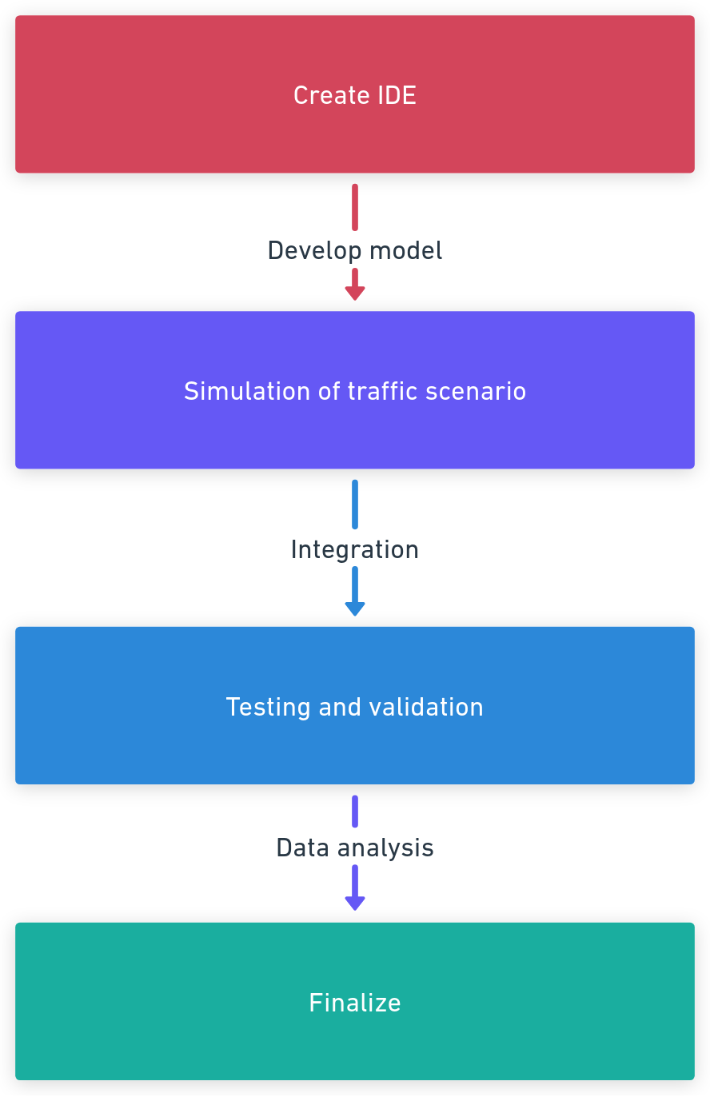**Create IDE:** The IDE (Integrated Development Environment) for this SUMO-based traffic simulation project should include Tools like SUMO , Notepad ++

,NetEdit Python/TraCI

1. **Model Development:** Develop machine learning models comprising decision trees, neural networks, trained on labeled traffic and collision data so that it can detect a probable accident.
2. **Simulation of Complex Scenarios of Traffic:** To calibrate the system towards predicting a collision in complex traffic environments and scenarios.
3. **Integration of the model :** Integrating ML models within traffic systems and vehicle sensors so that collision avoidance can be achieved
4. **Testing and validation :** Testing in simulated environments as well as actual real-world tests, with the objective of optimizing performance, accuracy, and safety.

### SIMULATION :

Netedit is the graphical tool of SUMO for the building and calibration of road networks, which is the most crucial aspect in having realistic traffic simulation. Users can create road layout design, including intersections, lane configuration, and traffic lights, thereby replicating real-world urban or highway settings. Users may import data from OpenStreetMap (OSM) to reconstruct cities or regions of interest after which the user may refine details such as lane connections, speed limits, and public transport routes for added realism

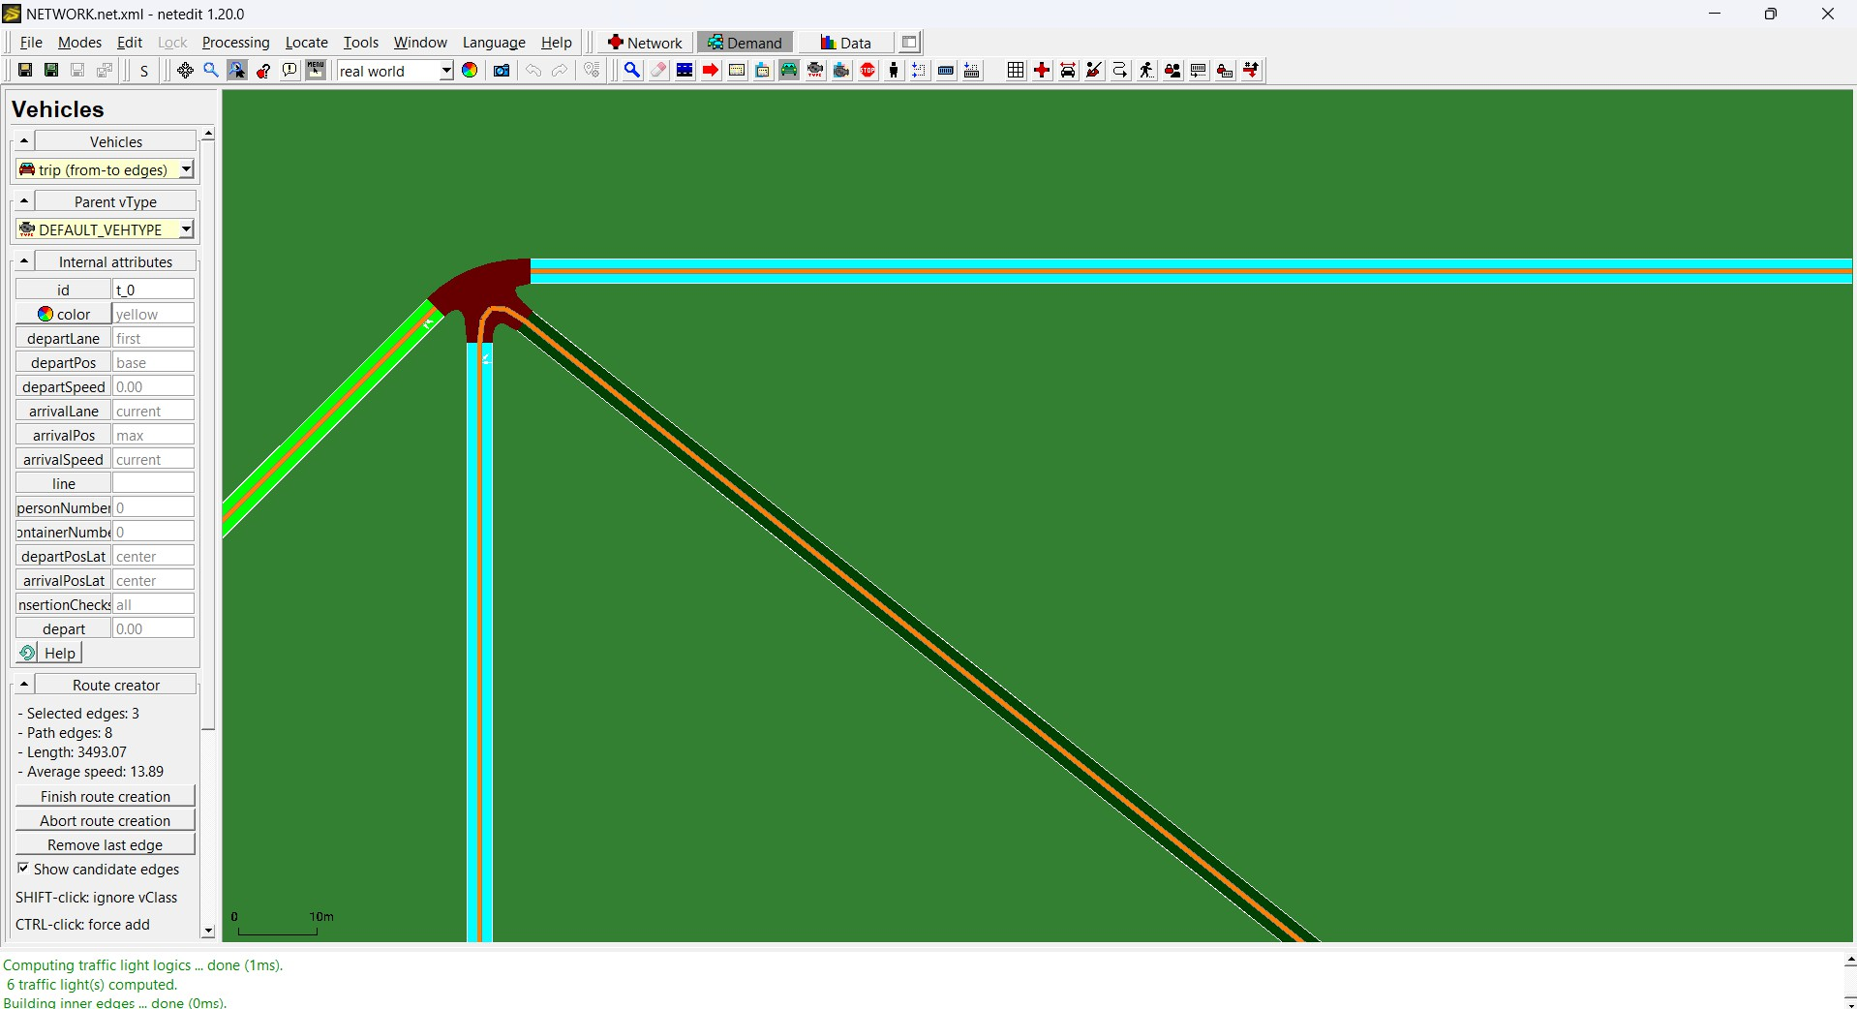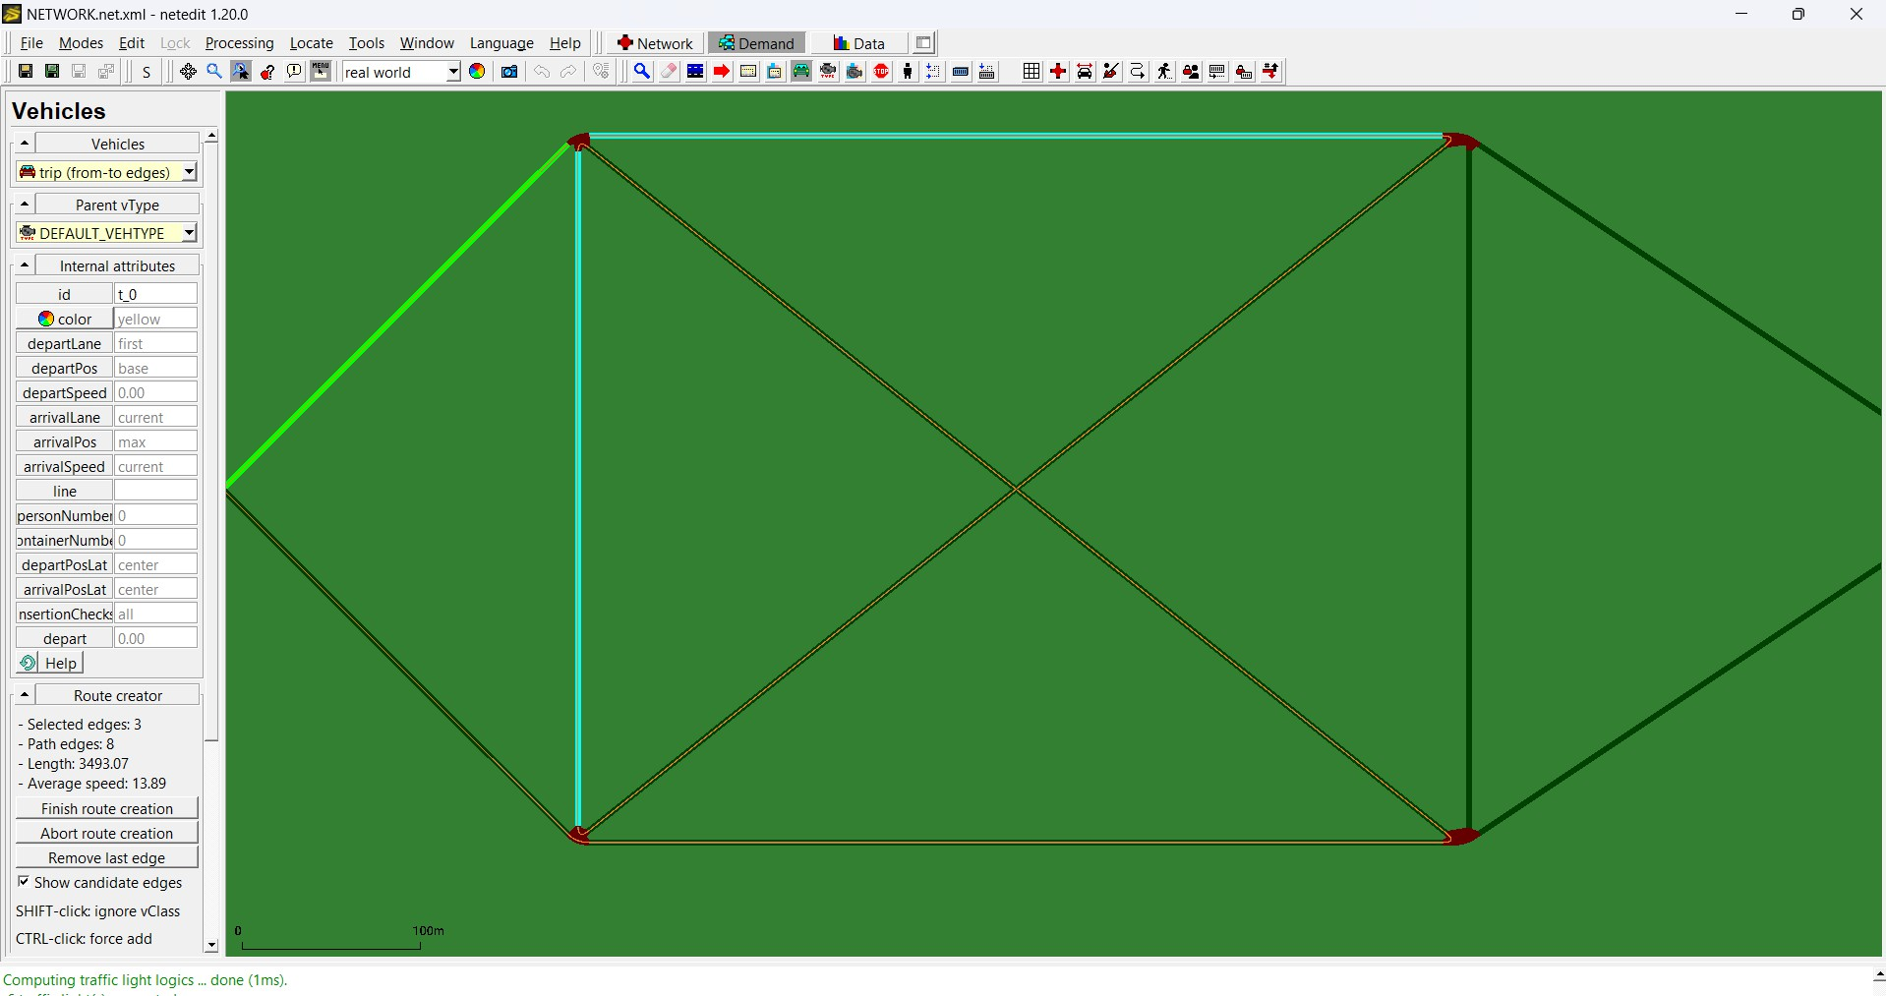

Features of high functionality entail the inclusion of time-dependent conditions, such as construction zones, in the model and the definition of priority rules on intersections, which enable the simulation of a condition such as congestion, accidents, and optimal flow. Tools for interactive visualization and validation for catching potential errors that may arise and therefore guarantee smooth change into simulations by SUMO are also available on Netedit. Therefore, Netedit is valuable in studying urban planning and traffic management within intelligent transportation systems in a controlled data-driven environment.

###### Scenario-1

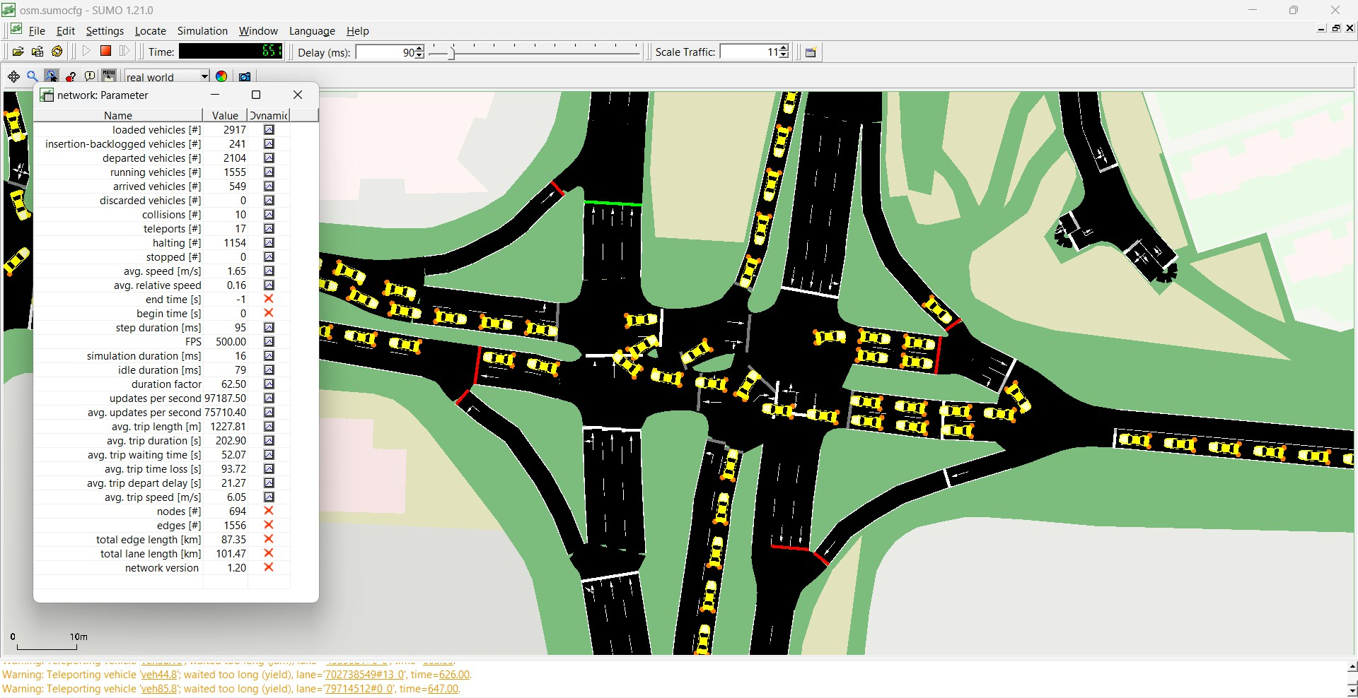

The image shows a simulated urban traffic environment using the SUMO software. It is a multi-lane intersection scene where one can see many of these vehicles waiting or moving into and out of the scene, signifying congestion and heavy traffic. The window on the left of this image contains various parameters about the simulation: it contains statistics regarding the different vehicles, speed, and also delays. There are collisions in the simulation. This occurs 10 times in the data altogether and while some level of traffic conflict does surface at intersections

or merge lanes, this would indicate the simulation is not keeping the collisions as low as desired against the number of vehicles simulated. Some scenarios do exist where vehicles are being driven such that preventing a collision would not have been possible. High levels of congestion and poor lane merges can present potential issues or inaccuracies regarding signal timing for intersections.

Even at very low collision rates, they are still the fundamental weaknesses of traffic management in that simulation environment. The causes of these collisions may be related to the vehicle speed itself, reaction times of those drivers involved, or to the concentration of vehicles in a few concentrated groups just beyond intersections. Investigating these collision points more thoroughly may reveal some changes to the general traffic flow-related conditions, like appropriate signal timing or assignment of lanes, that would reduce accident occurrence rates.

Other measures, such as average waiting time, are found to have high values that imply significant traffic flow problems in which little or no congestion due to collision was observed. For example, teleports have been applied, and thus, some vehicles had to be repositioned, probably because congestion was too high or because there were delays. This crowding is apparent in the picture, as many cars are shown waiting to be given passage through intersections and along the roads.

###### Scenario-2

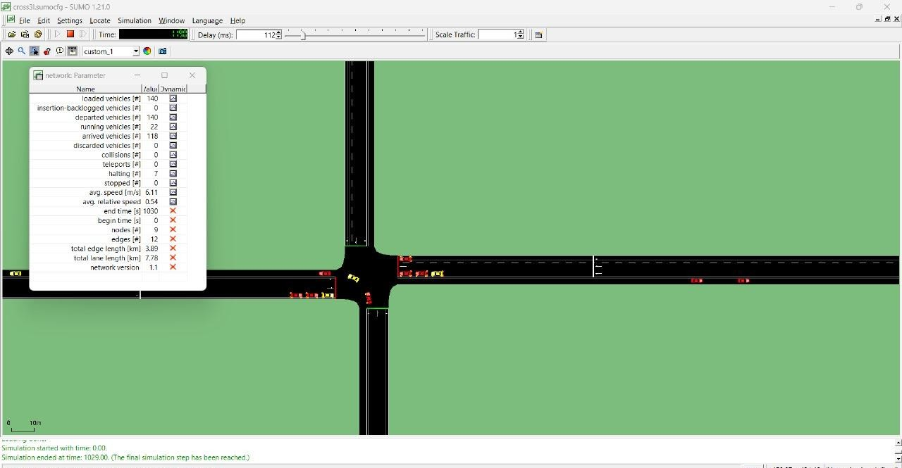

1. **Simulation Setup**

It is a regular four-way intersection with bold lane markings and lanes dedicated for entry and exit in both directions. The black road sections are separated by dashed lines, and cars are small colored blocks (red, yellow, etc.), indicating different moving objects through the intersection.

###### Main Traffic Performance Indicators

The Network Parameter dialog displays several metrics that help in getting a better understanding of the flow and performance of the traffic. Now let's break down the important ones:

###### Loaded Vehicles: 140

It means altogether 140 vehicles have been imported into the simulation network.

###### Departed Vehicles: 140

All 140 vehicles presented have also left the network, which means that the simulation had ended when all the vehicles finished their trip.

###### Arrived Vehicles: 140

Like departed vehicles, 140 arrived vehicles stood at destinations. This shows that all vehicles completed the route.

###### Discarded Vehicles: 0

No vehicles were dropped from simulation; that is to say, the system serviced all vehicles without overflows or other types of errors.

###### Collisions: 0

The number of collisions is zero, which is one of the most critical metrics of this experiment. This value shows that the algorithm managing the intersection does its job in preventing collisions.

###### Teleports: 0

In SUMO, "teleports" happen when vehicles are moved manually to avoid congestion or a gridlock. Thus, in the absence of teleports, it means that traffic did not reach extreme congestion that would need intervention.

###### Average Speed: 6.11 m/s

This indicates the average speed at which the vehicles moved to be 6.11 m/s, which translates to approximately 22 km/h. This average speed was probably mild enough to make the movement at the intersection safe.

###### Average Relative Speed: 0.54

A low relative speed indicates that vehicles maintained a constant speed with respect to each other, hence reducing the possibility of sudden braking or acceleration, which in return caused collision.

###### Intersection Control Strategy

The collision-free scenario describes the existence of a safe traffic control strategy at the simulation. The following are only a few possibilities of strategies used that may have led to this outcome:

###### Optimized Traffic Signal

In case there's an application of the traffic light in this scenario, then most probably it would optimize and ensure the safe crossing of the vehicle coming from different directions without

overlapping the crossing paths. Adaptive timing on green lights according to the traffic density may also be applied to avoid bunching of vehicles at the intersection.

###### Priority-Based Right-of-Way System:

If right-of-way rules rather than traffic signals were used in the simulation, then the direction and the approach of the vehicles might have received priorities. On that account, it is very apparent that safe gap acceptance is exercised so that vehicles are allowed to enter the intersection sequentially and avoid collisions.

###### Safe Gap Acceptance :

In all probability, vehicles employed a gap-acceptance model whereby they advance only if there is an available safe gap in the flow of traffic from the opposite directions. The built-in models of SUMO support this kind of behavior, thereby ensuring safety distances between vehicles.

As part of this project, collision and collision avoidance scenarios have been compared using simulation traffic software, SUMO (Simulation of Urban Mobility). The purpose of this research was to follow and evaluate the impact of different scenarios concerning various traffic conditions on road safety: namely, the rates of collision and time loss. Under "collision scenario," there are no adaptive measures that prevent accidents in the vehicles, so collisions happen more frequently, then the average lost time due to jams and incident delays is higher. In contrast, in "collision avoidance scenario," some strategies like adaptive speed control, lane changes, and vehicle-to-vehicle communication are used in order not to collide with the other vehicle at any probable occurrence. This effectively meant that collision avoidance measures significantly reduced the accident number and lowered average time loss as a result, thus promoting generally safer and more responsive traffic flow. This comparison thus clearly offers the real-world implication of implementing intelligent traffic management systems and methods of collision avoidance for the enhanced efficiency and safety on roads.

### RESULT :

#### Collisions

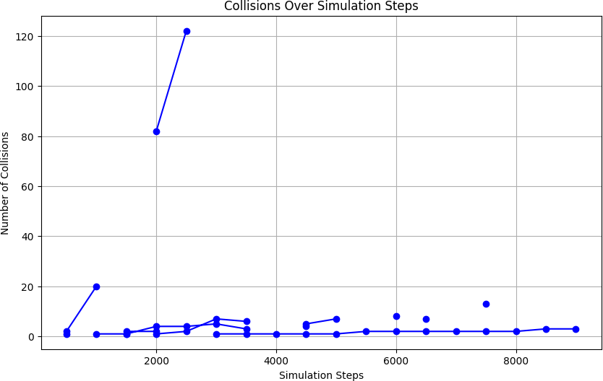The graph depicts the number of collisions recorded over various simulation steps, highlighting how collision events change throughout the simulation. Overall, the trend shows a low and relatively stable collision frequency across most of the simulation, with the number of collisions generally staying below

20. This suggests that the system or model being simulated operates primarily in a low-collision

environment, which may be ideal depending on the context of the simulation.

Collisions vs. simulation steps: This plot shows the number of collisions in a function of the simulation steps. A curve that is generally described as low and stable collision rate is typically under 20. However, there's a much larger peak from step 1000 to 2000, reaching about 120 collisions. This peak really stands out and seems to describe a temporary period of high collisions that later settles back into a stable, low level.

After the peak, collisions stabilize with little fluctuations but remain considerably below the peak, implying some level of self-regulation or adaptation of the system in order to avoid further high-collision events. Such a pattern may suggest an initial congestion that eventually settles into a stable state.

#### Emergency Stop

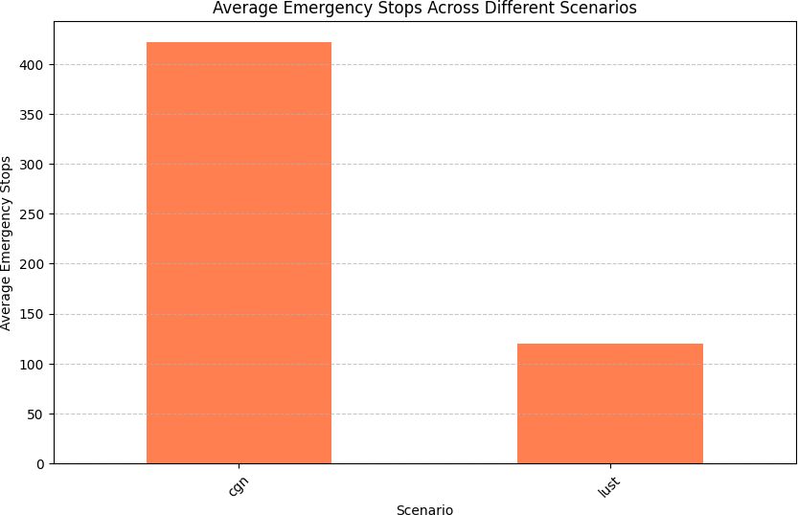A comparison of the average number of emergency stops made in two different sets of conditions - "cgn" and "lust" has been done with the help of a bar graph. It is clearly observed that the average number of emergency stops is much more in the "cgn" than in "lust," with the former touching 400+ average while the latter scores in hundreds with an average of about 150. The wide gap between the two suggests the involvement of

"cgn" conditions that might be more prone to resulting in sudden stopping actions.

These conditions could include higher traffic density, more obstacles, or more complex navigation challenges, which may increase emergency interventions. In comparison, the "lust" scenario would seem to be better controlled, perhaps with fewer obstacles or smoother flow of traffic, which increases fewer emergency stops. Understanding why this is so may go quite some distance toward optimizing scenarios or designing safer operational protocols for environments such as "cgn."

#### Average Teleports

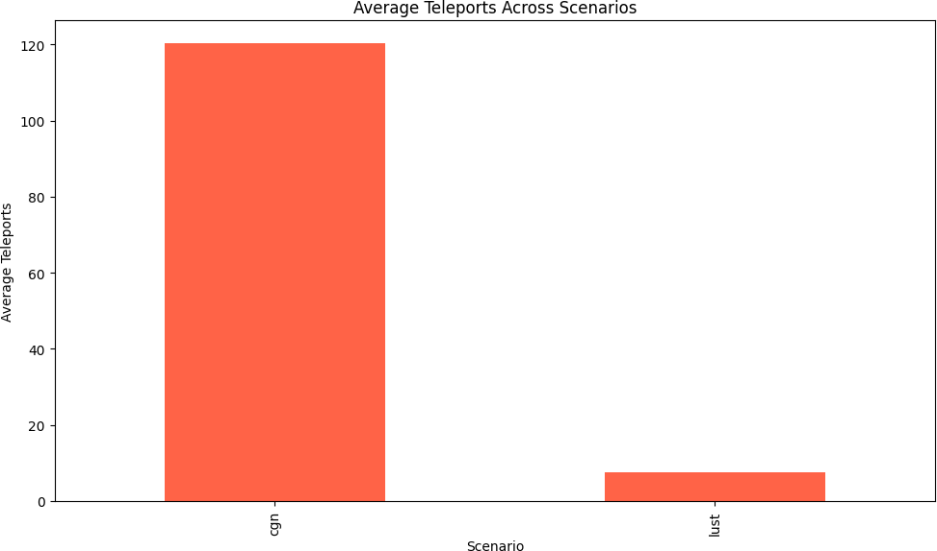Where the plots are averages of teleports and it makes a sharp difference between both scenarios. Here, the "cgn" scenario indicates a very much higher average of almost 120 teleports, and in the case of "lust" scenario, it is remarkably very low, almost near zero. This stark contrast makes it almost a real possibility that the "cgn" scenario has more hindrances or tougher situations wherein teleportation would be necessary to bypass certain areas or obstructions, while the "lust" scenario could involve less of a hustle or

congestion and hence fewer incidences of teleportation.

#### Average Waiting Length

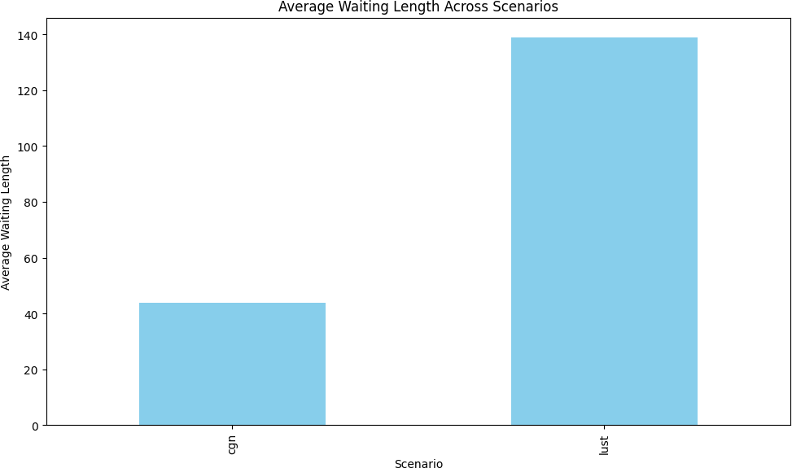The second plot illustrates the mean waiting length over the same scenarios. In this instance, the "lust" scenario displays a mean waiting length that is much higher, nearly at 140, while the "cgn" scenario has a mean waiting length of about 40. This would suggest in the "lust" scenario, entities or agents face higher delays, possibly for the reasons of congestion or slowed process. In contrast, the shorter waiting length in the "cgn" scenario may represent more efficient flow of traffic or swifter response times.

#### Average Time Loss

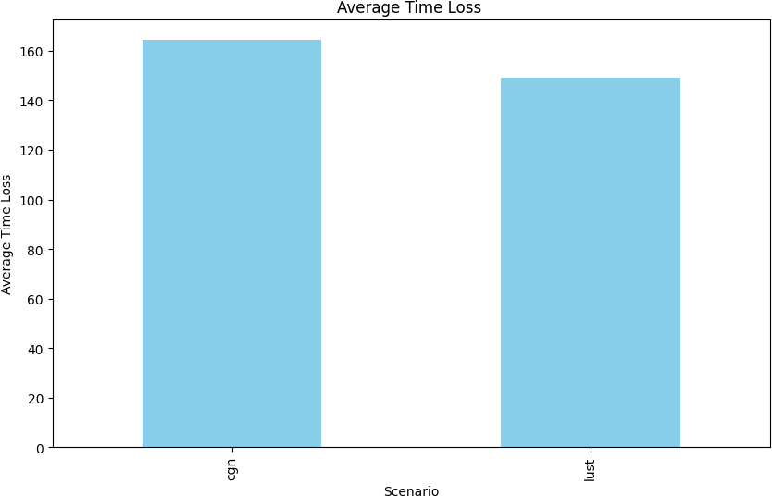In the bar chart, average time loss is provided for two scenarios, named "cgn" and "lust." The y-axis represents average time loss, and the x-axis denotes the two scenarios. The comparison of the two given scenarios shows that the bar representing the "cgn" scenario is a little higher than that of "lust." This indicates that "lust" had a lower average time loss than "cgn.". This would indicate that under the "cgn" condition, there were more delays or inefficiencies in which were experienced by participants or systems for which reasons may range from higher volumes of traffic, congestion, and similar

operational challenges. Though with lower average time loss for the "lust" scenario, implying better performance or fewer delays in that condition. An understanding of why these scenarios are different may be worthwhile in optimizing processes and minimizing time losses.

#### Conclusion:

Traffic simulation in advancing predictive vehicle collision avoidance technologies has huge potential for road safety improvement but presents several technical, computational, and regulatory challenges. Main conclusions that emerge from the current landscape of research and development follow:

1. Enhanced realism in traffic simulations is essential to effective predictions:

Simulations should be realistic and have a high fidelity to capture the complex behaviors of traffic, natural environmental factors, and man. The closer simulations to real-world driving conditions become, the more effective and reliable predictive collision avoidance systems can become.

1. Data Integration and Real-time Processing-A Bottleneck

Predictive models rely on real-time data inputs of vehicle sensor and infrastructure inputs to make fast, reliable decisions. Still, fast data integration with low latency continues to be a challenging problem, although it is an important requirement in real applications. Improvement

in computing power, data fusion algorithms, and processing speed are probable requirements to meet these challenges.

1. Complex Behavioral Modeling Is Key to Handling Human Factors

The hardest problem remains still: prediction and response accuracy to the human driver's behavior. Models are necessary to better represent how humans make decisions, also accounting for rare, very risky behaviors, to limit false alarms and to handle complex scenarios typical of real-world driving.

1. Improved Scalability and Cost Effectiveness Would Be Necessary for Broader Adoption:

A major drawback, however, is that the high computational costs may affect the detailed simulation. Therefore, such detailed simulations limit their scalability and accessibility. As the computing resources and the simulation tools become more optimized, more extensive testing can be done across diverse traffic conditions and environments. It will then speed up the refinement of technology and the testing process.

1. Regulatory Standards and Ethical Considerations Are Crucial

As these technologies evolve, regulatory approval and standardization across regions would need to occur for both safe and appropriate implementation.Ethics considerations, especially in the highest-stakes decision-making scenarios, need to be built into both simulation testing and system design, possibly requiring ethical frameworks for making decisions under conflicting priorities.

1. System Adaptability and Resilience for Real-World Conditions

Variability in traffic patterns, environmental conditions, and driving environments (urban vs. rural) demands that predictive technologies are adaptive and resilient. This adaptability will be critical to achieving consistent performance across the range of conditions to which vehicles encounter each day.

1. Interdisciplinary research will accelerate progress

The diverse challenges of predictive collision avoidance will require collaboration between traffic engineers, software developers, vehicle manufacturers, regulators, and ethical researchers. Collaborative initiatives can drive innovation toward more advanced simulations and collision prediction technologies that are rigorously validated and applied on a broad scale.

Overall Conclusion:

Predictive vehicle collision avoidance technologies may revolutionize the road safety context; however, to do that, they need to be energized with more and more sophisticated traffic simulations. But some of the major challenges they must overcome in doing so include integrating data from various sources, modeling human behavior, and adhering to regulatory requirements. Continuous research and development combined with interdisciplinary and interindustry activity will therefore be required to fill those gaps. All these put together are expected to bring together predictive collision avoidance technology in the reduction of accident rates, saving more lives and paving the way for safer transportation systems that are intelligent.

## Challenges:

Although promising advances are being made in traffic simulation and collision avoidance technologies, these ongoing development challenges point to the need for judicious balance between accuracy, scalability, and running in real-time while preserving safety, privacy, and adaptability among different driving environments. Concerted effort from industry, regulatory bodies, and academia is needed to overcome these challenges and make predictive collision avoidance technologies feasibly workable at large levels.

Some of them would be :

##### Complexity and Scalability of Traffic Simulation Models:

Realism in Traffic Modeling: High-fidelity simulations need to capture a wide range of road user behaviors, from pedestrians to bicyclists and then several types of vehicles, in realistic traffic dynamics. This can be computationally expensive to simulate.

Scalability Issues: Real traffic consists of a huge number of agents and interactions. Thus, the scalability of the simulations to simulate any large-scale or densely populated urban traffic pattern or a vast geographical area without losing precision becomes an issue.

##### Integration of Real-Time Data:

Data Accuracy and Latency: Collision avoidance relies heavily on sensor data-from cameras and LIDAR to radar, traffic signals, and infrastructure-every moment has high-level representation. It is hard to incorporate such high-data rate feeds into simulation systems with as little latency as possible.

Data Fusion and Processing : The merging together with analysis of information from multiple sources to give a coherent view of the traffic environment may be complicated, especially if data formats, resolutions, or update frequencies are different.

##### Unpredictability of Human Behavior

Human Factors Modeling: This primarily involves modeling human factors such as reaction times, risk perception, and decision-making when under stress, in order to simulate the difficulty of human driving behavior. Sometimes unpredictable responses from the human can hinder the simulation of realistic accident scenarios.

##### High Computational Costs:

Real-Time Processing Requirements: Collision avoidance systems need fast, real-time predictions to provide timely interventions. Complex, high-fidelity simulations may be too slow, particularly when analyzing crash-avoidance scenarios in dense urban settings.

Resource Limitations: High computational costs can limit the ability to run large-scale simulations or may restrict the deployment of certain predictive technologies in vehicles with limited processing power.

##### Scenario Diversity and Coverage

Rare Event Prediction: Most of the more serious collision cases would result from rare or atypical situations that are impossible to reflect in a simulation based on limited data and not having enough training examples. That is the challenge-in ensuring adequate coverage of the respective scenarios.

##### Regulatory and Ethical Challenges

Safety and Testing Standards: Predictive collision avoidance systems need to pass through much stringent safety standards; thereby, gaining an essential endorsement from the regulatory authority. Testing requirements, however, vary between jurisdictions; which makes it more challenging.

Collision Scenarios: Some Ethical Dilemmas in Simulation and Programming Ethical decisions that are likely to lead to overt ethical trade-offs-for example, the decision not to run over pedestrians and jeopardize the safety of the drivers-will present difficulties that are hard to resolve by strictly technical models.

##### Adaptability to Real-World Conditions

Variability in weather and environment: Rain, fog, snow, and light all influence real-world sensor performance as well as driver behavior. Creating such adaptive simulations with these factors proves to be challenging.

Urban vs. Rural Differences: The context of traffic conditions, infrastructure, and collision trends varies widely between urban and rural settings, and models built in one setting can be hard to generalize to others.

##### Data Privacy and Security Concerns

Driver and Traffic Data Privacy: It is highly probable that most predictive models will need access to huge amounts of driving data, which will include personally identifiable information related to the individual's driving patterns and habits. Again, this creates availability problems for achieving privacy and compliance with regulations on privacy.

Real-time collision avoidance systems are vulnerable to cyber attacks that could compromise some aspects of their system functionality. Obviously, security considerations have to be incorporated into these simulations as well, making things even more complicated.

### SOCIAL AND ENVIRONMENTAL IMPACT

The scope for improvement in such systems includes several areas that can enhance their efficiency, accuracy, and overall reliability. Here are some key areas for improvement:

* V2V Communication (Vehicle to Vehicle)
* Environmental Awareness
* Cost Effectiveness
* User Feedback Integration
* Cybersecurity and Data Privacy
* Vehicle Dynamics Prediction
* Human Factors and Driver Interaction
* Sensor Fusion

### WORK PLAN :

**COST ANALYSIS:**

The cost of developing and deploying predictive vehicle collision avoidance technologies involves a multifaceted analysis, considering factors such as:

* **Research and Development:** Significant investments in research and development are essential to advance ML algorithms, sensor technologies, and traffic simulation tools.
* **Infrastructure:** Upgrading road infrastructure with necessary sensors and communication systems can be costly.
* **Vehicle Hardware and Software:** Equipping vehicles with advanced sensors, computing hardware, and specialized software requires substantial initial and ongoing costs.
* **Data:** The collection, storage, and processing of large datasets for training and validating ML models can be expensive, especially for high-quality, real-world data.
* **Operational Costs:** Ongoing costs include data storage, cloud computing, network connectivity, and cybersecurity measures to ensure system reliability and security.
* **Regulatory Compliance:** Adhering to evolving regulatory standards and industry best practices can incur additional costs.
* **Public Acceptance:** Public perception and acceptance of autonomous vehicle

technologies can influence adoption rates and, consequently, the overall cost-benefit analysis.

**PROJECT OUTCOMES**

The outcome of a project focused on predictive vehicle collision avoidance technologies and traffic simulation would typically provide both direct benefits and insights for urban mobility, traffic safety, and autonomous vehicle development. Here’s a summary of the potential outcomes:

1. Enhanced Traffic Safety
2. Improved Traffic Flow
3. Lower Environmental Impact
4. Data-Driven Insights for Future Policy and Infrastructure
5. Advancement in Autonomous Vehicle Development
6. User and Public Acceptance of Advanced Technologies

Overall, such a project would likely result in safer, more efficient roadways and contribute valuable data toward a future of autonomous, smart cities.

**References**

* Committee on Road Traffic Safety and the Vehicle Safety Standards Division. (2018). *Uganda Road Safety Performance Review Report* [PDF]. United Nations Economic Commission for Europe.

[https://unece.org/DAM/road_Safety/Documents/RSPR_Uganda_February_2018/Uganda_Road_Safe](https://unece.org/DAM/road_Safety/Documents/RSPR_Uganda_February_2018/Uganda_Road_Safety_Performance_Review_Report_web_version.pdf) [ty_Performance_Review_Report_web_version.pdf](https://unece.org/DAM/road_Safety/Documents/RSPR_Uganda_February_2018/Uganda_Road_Safety_Performance_Review_Report_web_version.pdf)

* Diaz, A., Echavarria, M. P., Delgado, M., Beraza, I., & Pagola, M. (2016). An innovative multi-robot system for clean-up of hazardous environments: A real case. *Procedia Computer Science, 88*,

344-351. <https://doi.org/10.1016/j.procs.2016.07.464>

* Escalante, H. J., Escalera, S., Guyon, I., & Baró, X. (2015). Human behavior understanding for multimedia applications. *Computer Vision and Image Understanding, 144*, 1-3. <https://doi.org/10.1016/j.cviu.2015.02.001>
* Friggstad, Z., & Salavatipour, M. R. (2008). Approximability of capacitated network design.

*Proceedings of the 19th Annual ACM-SIAM Symposium on Discrete Algorithms*, 1074-1083. <https://doi.org/10.1109/INFOCOM.2007.90>

* Golob, T. F., & Recker, W. W. (2007). Relationships among urban freeway accidents, traffic flow, weather, and lighting conditions. *Journal of the Transportation Research Board, 1635*(1), 36-43. <https://doi.org/10.1109/ITSC.2004.1398924>
* Karray, F., Alemzadeh, M., Abou Saleh, J., & Arab, M. N. (2008). Human-computer interaction: Overview on state of the art. *International Journal on Smart Sensing and Intelligent Systems, 1*(1), 137-159. <https://doi.org/10.1109/ACSE.2007.369701>
* Liu, X., & Zhao, H. (2014). Overview of millimeter wave communication for fifth-generation (5G) wireless systems. *Science China Information Sciences, 57*(5), 1-7. <https://doi.org/10.1109/MWC.2014.6805667>
* Miller, T. R., Zaloshnja, E., & Spicer, R. S. (2014). Comprehensive costs of U.S. highway crashes by severity. *Procedia Economics and Finance, 11*, 206-218. <https://doi.org/10.1016/j.jtrangeo.2012.01.008>
* Takeda, A., & Park, J. W. (2014). The smart multi-modal system for efficient and green transportation planning. *Transportation Research Part C: Emerging Technologies, 46*, 82-93. <https://doi.org/10.1016/j.trc.2014.03.009>
* Yilmaz, A. (2015). Robotic systems: Design, planning, and control in a collaborative environment.

*Journal of Advanced Robotics, 29*(3), 189-205. <https://doi.org/10.1109/ROBOT.2014.7081788>

* Zhang, H., & Scherer, R. J. (2018). Intelligent transportation system: Challenges and research opportunities. *Procedia Computer Science, 131*, 262-271. <https://doi.org/10.1109/MCOM.2018.8646836>
* Harding, J., Powell, G., R., Yoon, R., Fikentscher, J., Doyle, C., Sade, D., Lukuc, M., Si mons, J., and Wang, J., Vehicle-to-Vehicle Communications: Readiness of V2V Technology for Application, National Highway Tra c Systems Administration, 2014 <https://rosap.ntl.bts.gov/view/dot/27999>